Exploration: Finding Patterns Name:________________________________
Case 5
Case 1
Case 4

What do you Notice? | What do you Wonder?
What “Wondering” are we going to investigate?

My thinking…..

Conclusion:

Exploration: Finding Patterns Name:________________________________
Case 5
Case 2
Case 6

What do you Notice? | What do you Wonder?
What “Wondering” are we going to investigate?

My thinking…..

Conclusion:

Exploration: Finding Patterns Name:________________________________
Case 2
Case 5
Case 1

What do you Notice? | What do you Wonder?
What “Wondering” are we going to investigate?

My thinking…..

Conclusion:

Exploration: Finding Patterns Name:________________________________
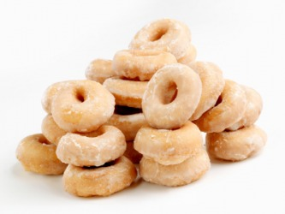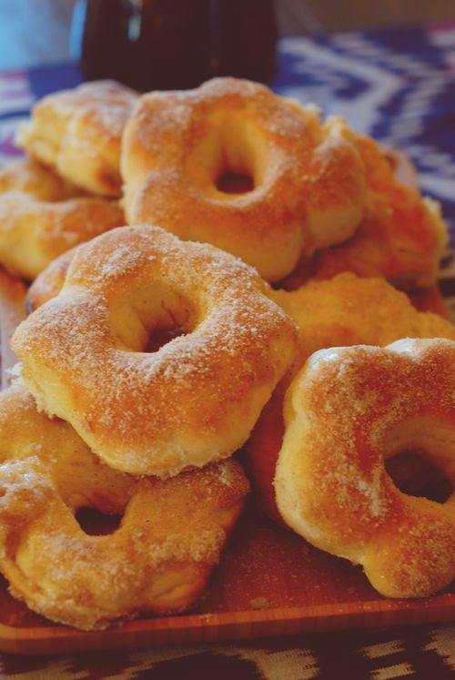
50 Donuts 32 Donuts 20 Donuts 8:00am 11:00 am 1:00 pm

What do you Notice? | What do you Wonder?
What “Wondering” are we going to investigate?

My thinking…..

Conclusion:

