Dotplots Level 1 Name:___________________

Create two dotplots using the data below. Make two separate plots but scale your axis the same for both graphs for comparison.

Data Set A:
7 | 21 | 18 | 22 | 9 | 16 | 12 | 17 | 17 | 16

Construct a dotplot for Data Set A.

Data Set B:
14 | 16 | 18 | 20 | 12 | 14 | 16 | 12 | 20 | 19

Construct a dotplot for Data Set B

Comment on the similarities and differences between Data Set A and Data Set B. Think about comparing the centers and spreads of the dotplots.

Dotplots Level 2 Name:___________________

The data below give the student-to-teacher ratio (how many students per 1 teacher on average) for 20 different schools…10 with a high number of students meeting standards and 10 with a low number of students meeting standards.

Here are the student-to-teacher ratios at 10 schools where a high number of students are meeting standards
7 | 21 | 18 | 22 | 9 | 16 | 12 | 17 | 17 | 16

Construct a dotplot for this data

Here are the student-to-teacher ratios at 10 schools where a low number of students are meeting standards:
14 | 16 | 18 | 20 | 12 | 14 | 16 | 12 | 20 | 19

Construct a dotplot for this data

Comment on the similarities and differences between the two distributions

Dotplots Level 3 Name:___________________

A certain state’s education commissioner released a new report card for all the public schools in that state.
This report card provides a new tool for comparing schools across the state. One of the key measures that can be computed from the report card is the student-to-teacher ratio, which is the number of students enrolled in a given school divided by the number of teachers at that school.

The data below give the student-to-teacher ratio at the 10 schools with the highest proportion of students meeting the state reading standards in the third grade and at the 10 schools with the lowest proportion of students meeting the state reading standards in the third grade.

Ratios in the 10 Schools
with Highest Proportion of Students Meeting Standards
7 | 21 | 18 | 22 | 9 | 16 | 12 | 17 | 17 | 16

Ratios in the 10 Schools
with Lowest Proportion of Students Meeting Standards
14 | 16 | 18 | 20 | 12 | 14 | 16 | 12 | 20 | 19

- Display a dotplot for each group to compare the distribution of student-to-teacher ratios in the top 10 schools with the distribution in the bottom 10 schools.

- Comment on the similarities and differences between the two distributions.

Source: http://apcentral.collegeboard.com/apc/public/repository/ap08_stat_form_b_frq.pdf
http://apcentral.collegeboard.com/apc/public/repository/ap08_statistics_form_b_sgs.pdf

Scoring Guidelines from AP:

Solution:

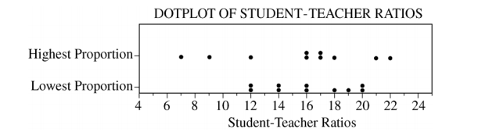

A similarity is that the two distributions are centered in approximately the same place. A difference is that the distribution for the schools with the lowest proportions of students meeting the standards is less variable.

Part 1: Dotplot Construction
Essentially correct (E) if the dotplots are given with appropriate labels and scales (minor errors in the
placement of the dots are okay).

Incorrect (I) if the labels or scales are missing OR if a histogram with dots or a scatterplot is given

Part 2: Center
Essentially correct (E) if the response states that the two distributions have approximately the same center (no numerical values are required) OR if the response states that the means are slightly different.

Incorrect (I) if measures of center are not given OR if they are given, but there is no comparison of the center of the two distributions.

Part 3: Spread
Essentially correct (E) if the response states that the spread of the two distributions differs (no numerical
values are required).

Incorrect (I) if measures of spread are not given OR if they are given, but there is no comparison of the spread of the two distributions.

Note: Usually distributions are described in terms of shape, center, and spread. However, with small data sets, shape is difficult to judge, so no comparison of shape is required.

