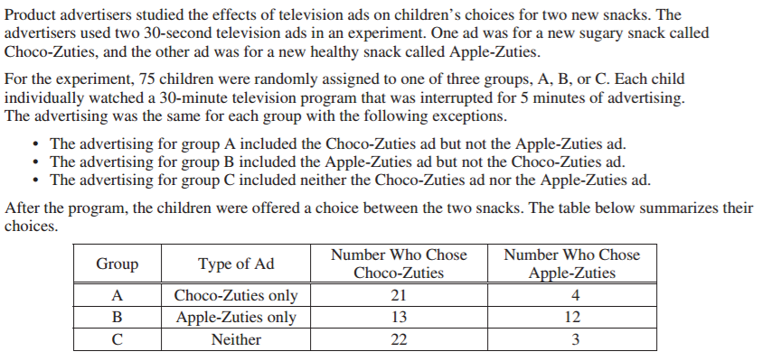

Write a few sentences describing the effect of each ad on children’s choice of snack

